Mario Reyes

Professor Burroughs

BIO 307 A

07 June 2024

Plant Phylogeny Lab

### Chara sequence:

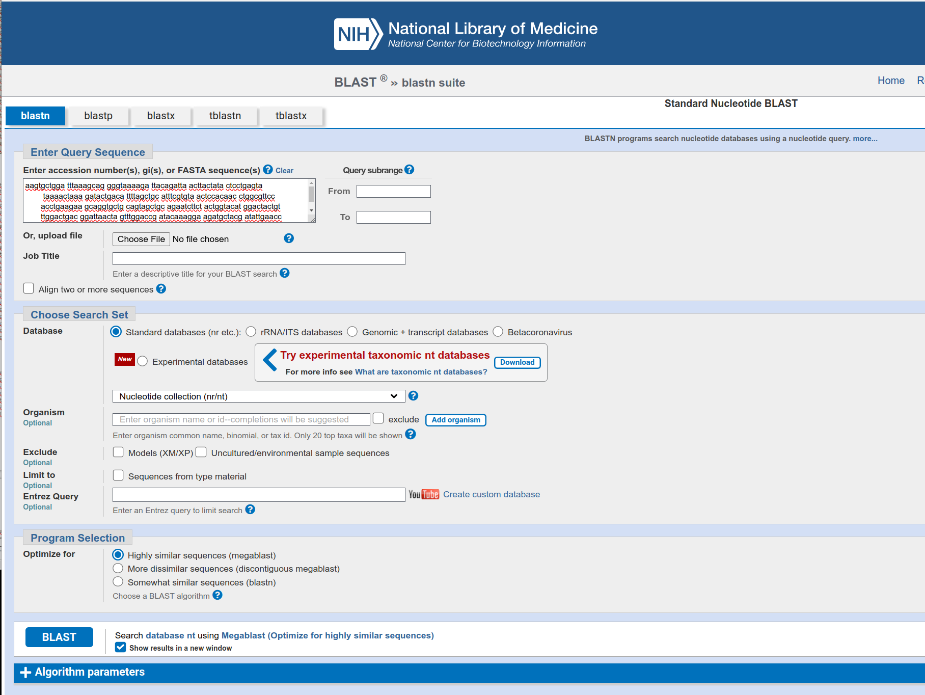

Results for Chara Results for Marchantia 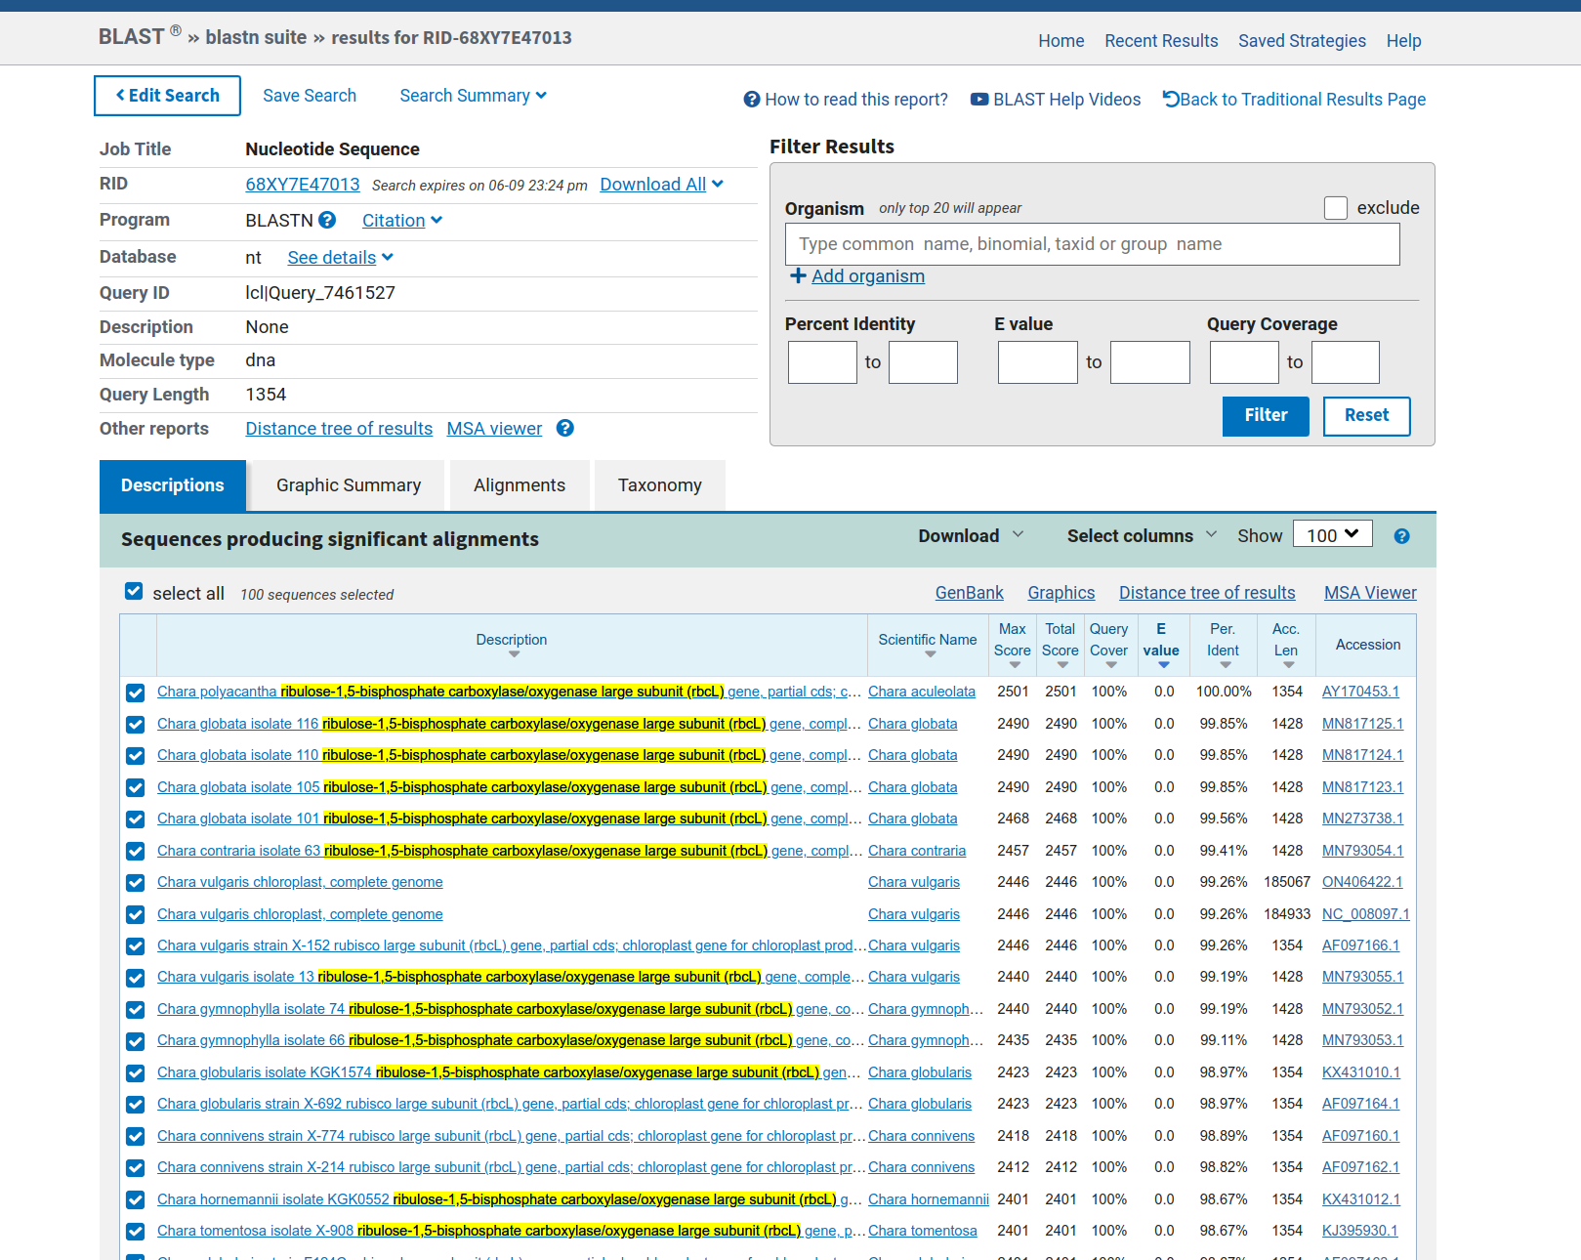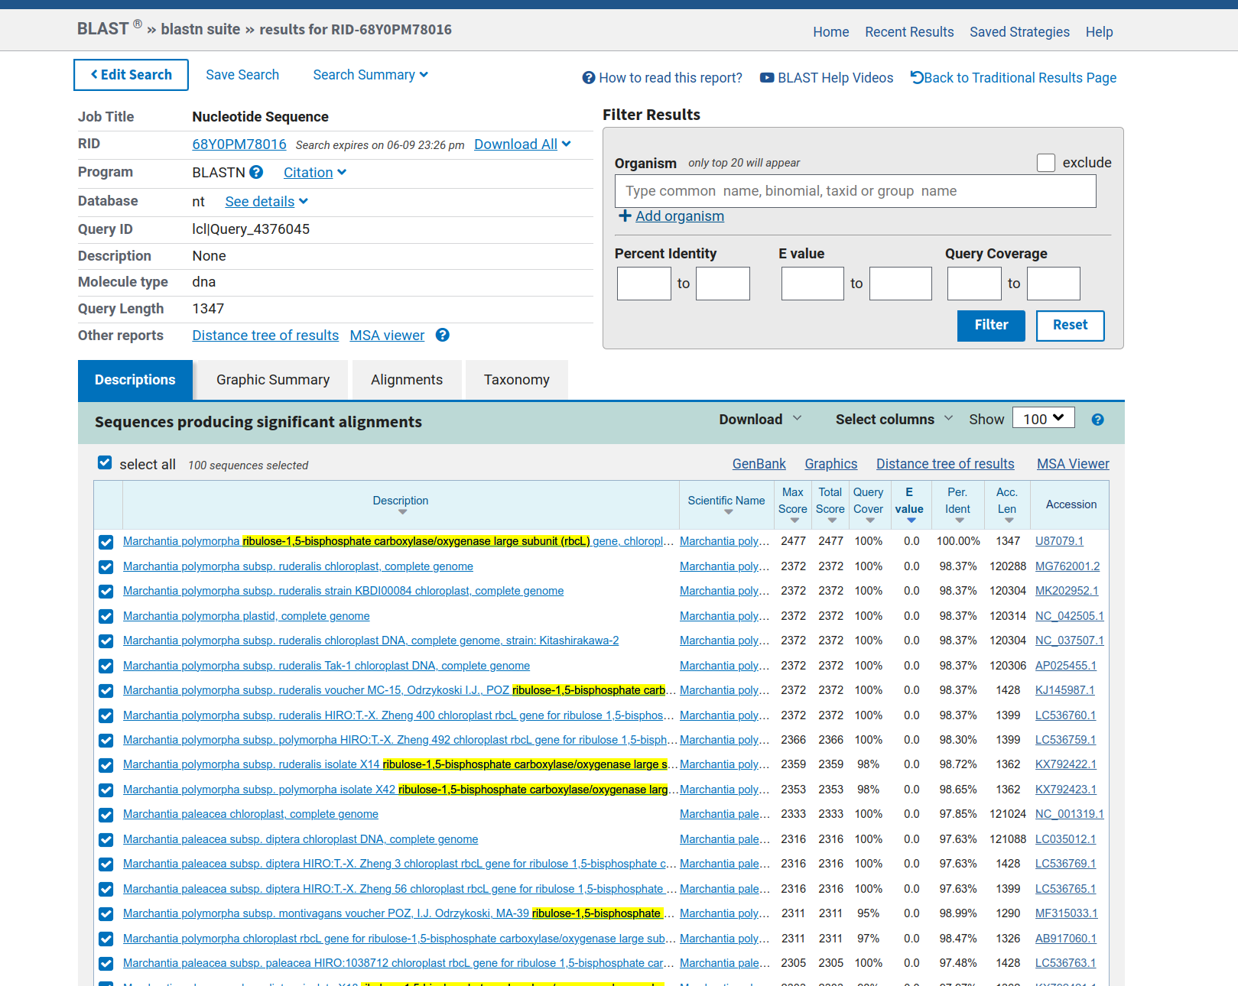

Results for Polytrichum Results for Equisetum

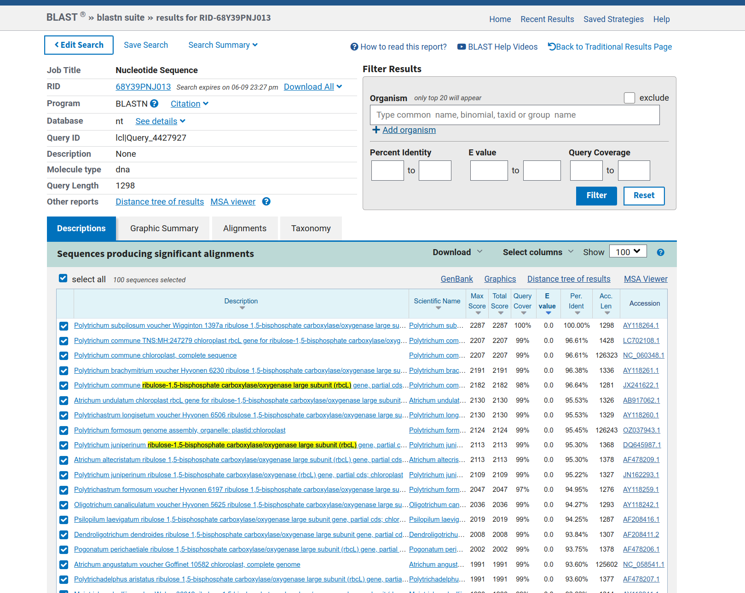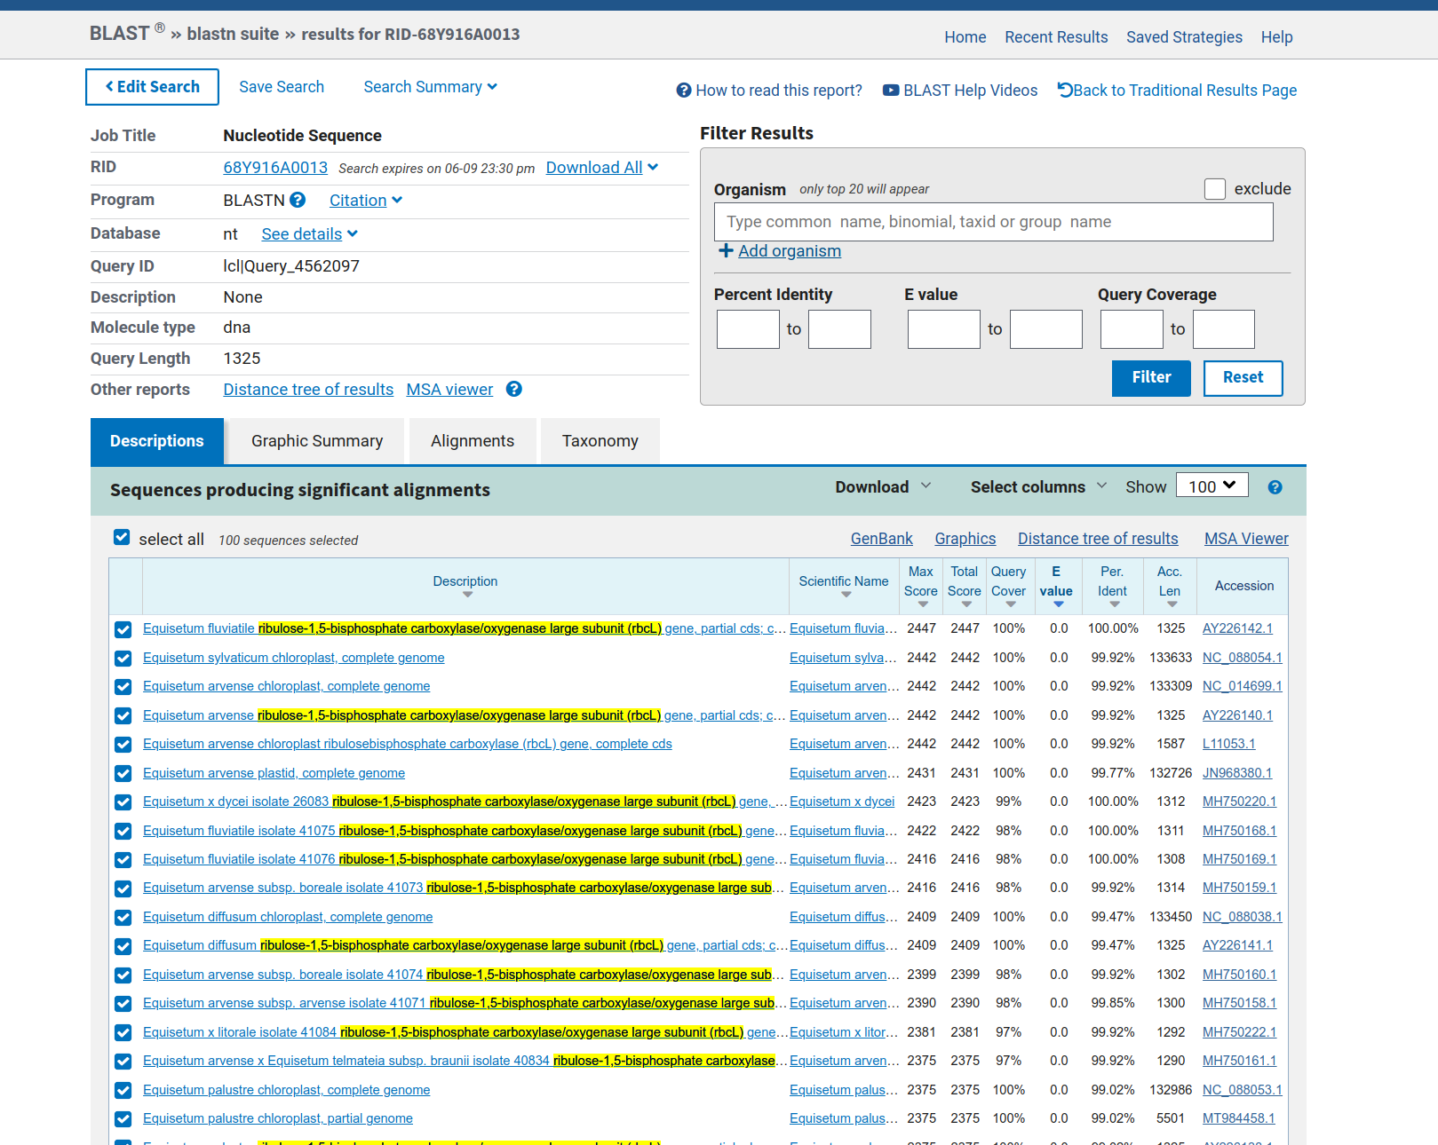

Results for Serpocalum Results for Pinus

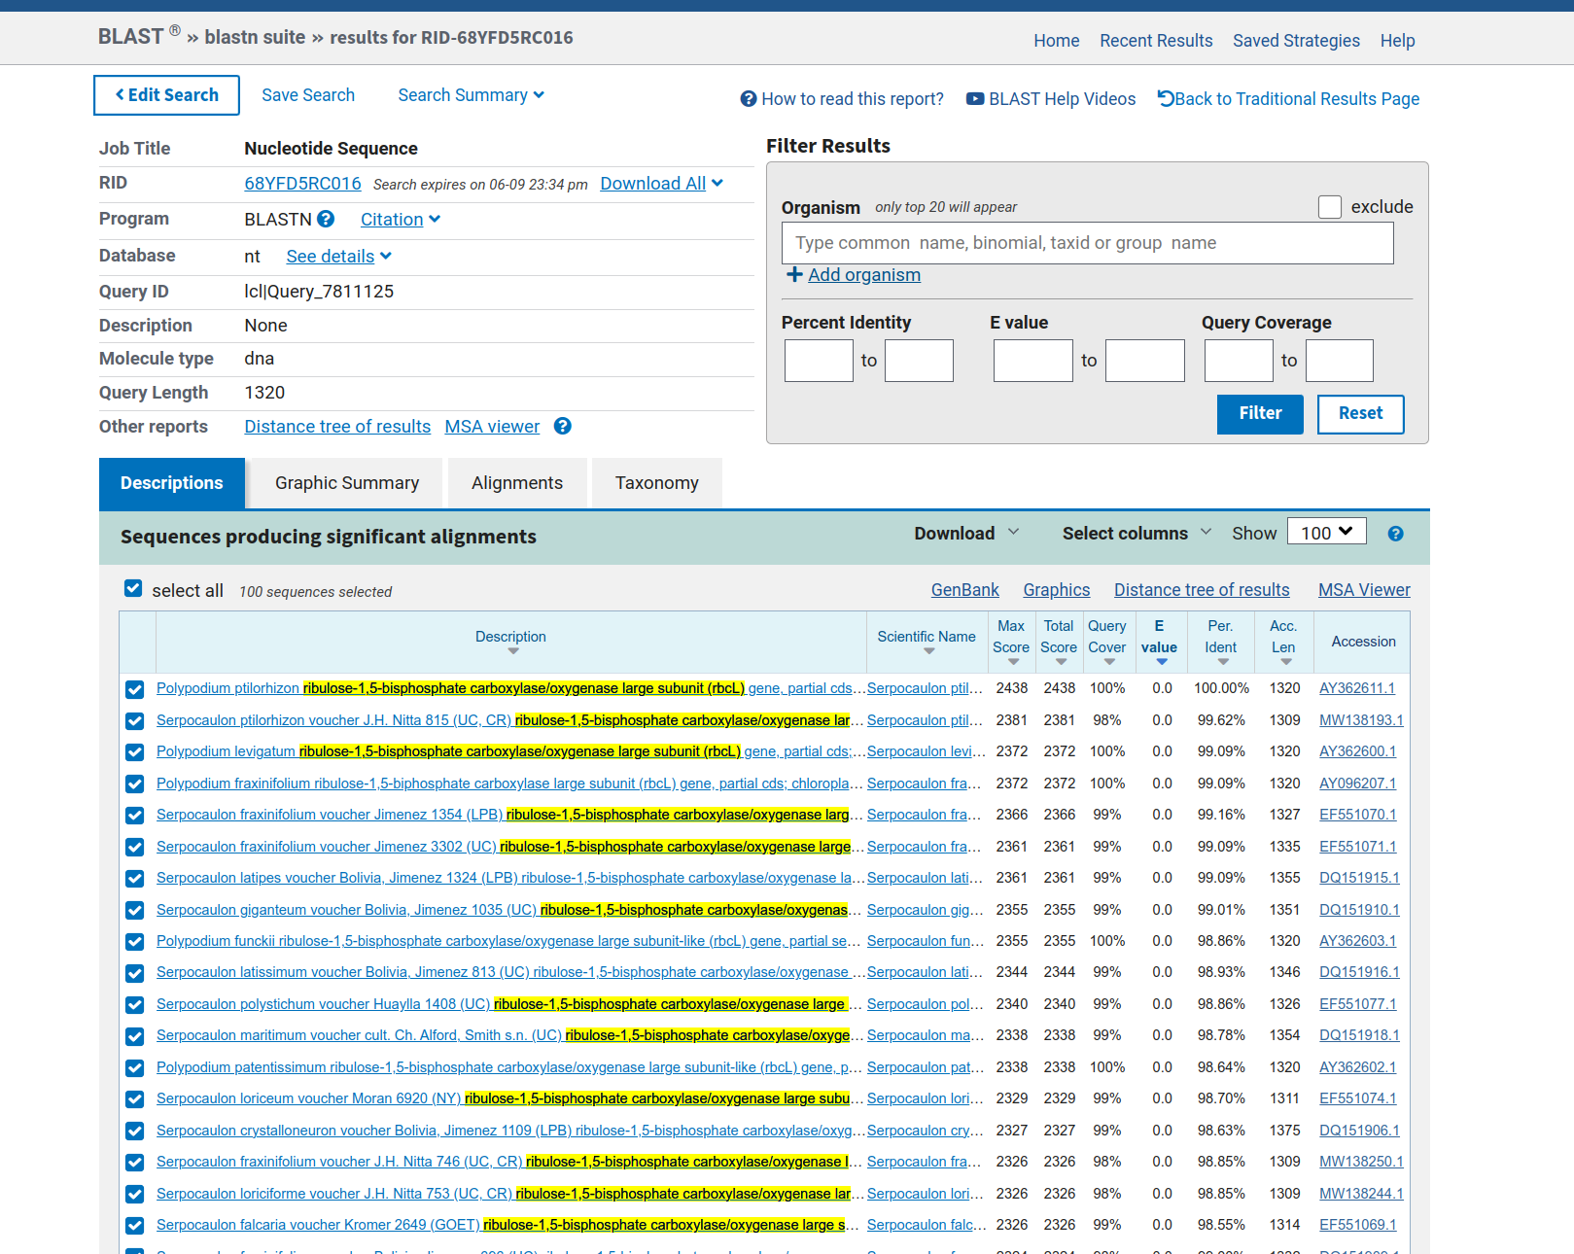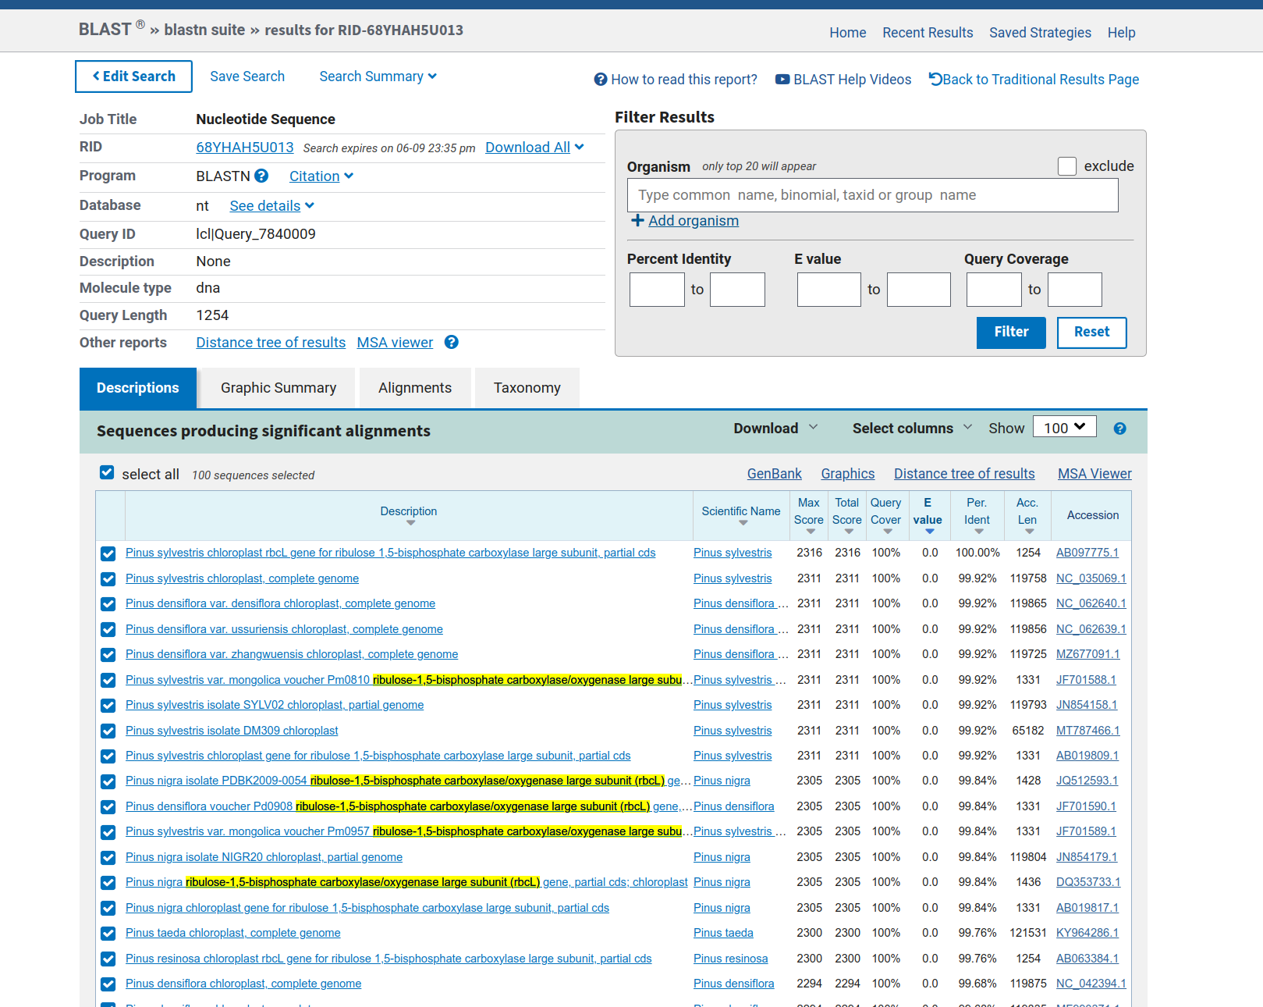

Results for Zamia Results for Arabidopsis

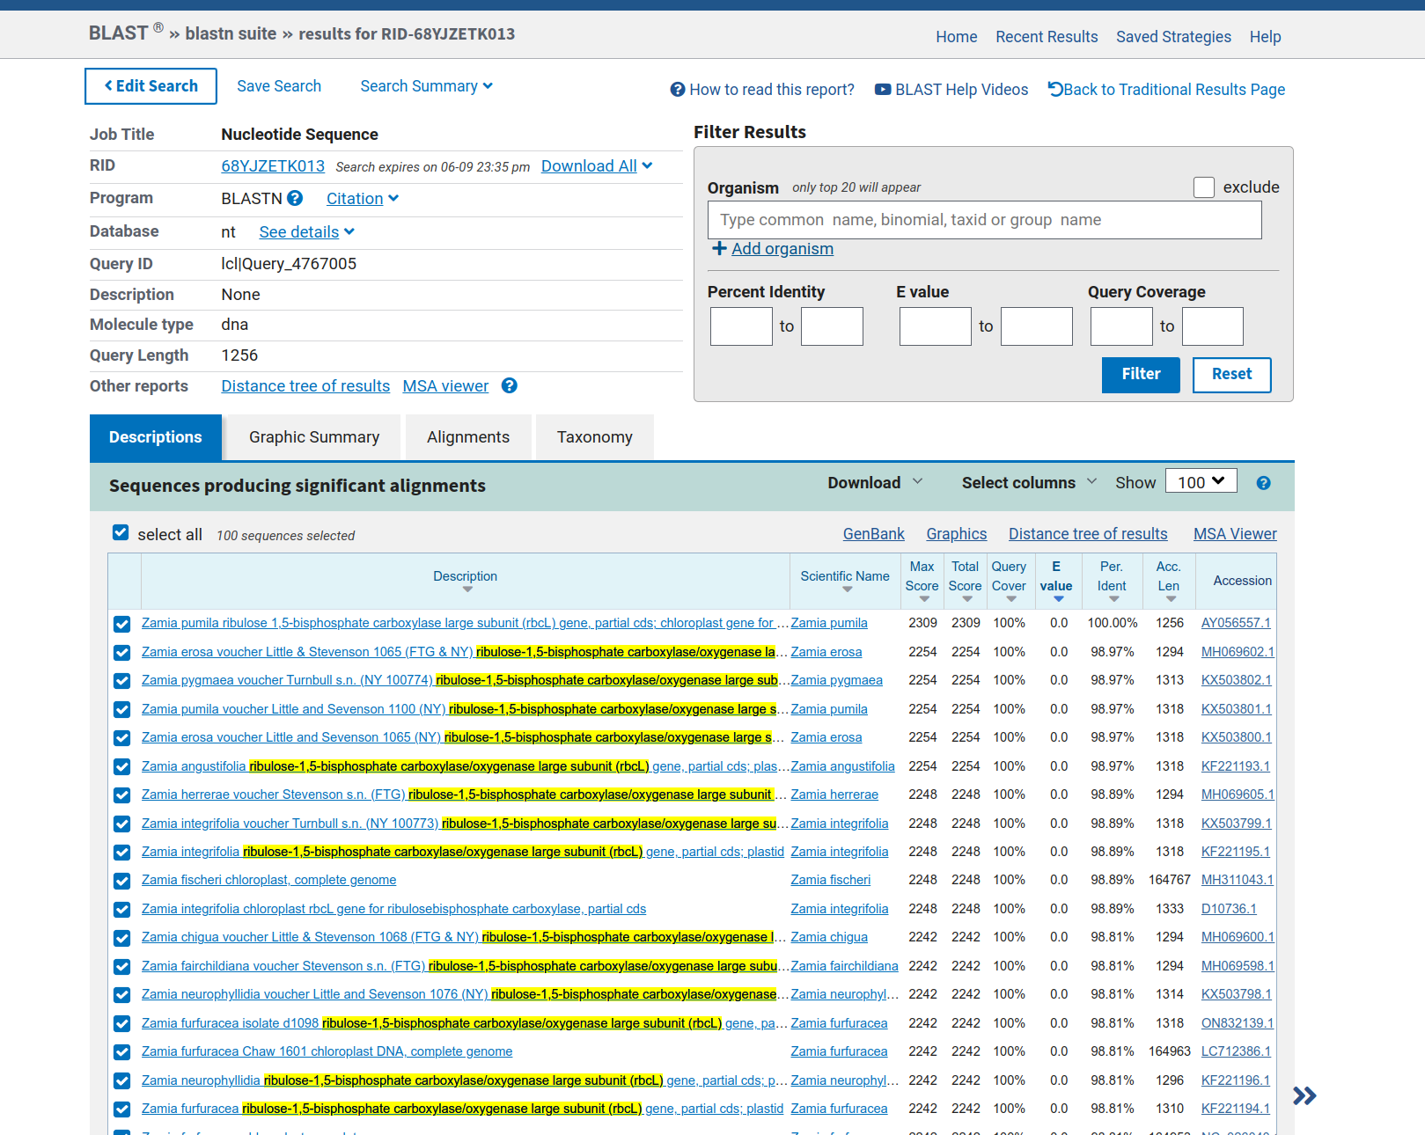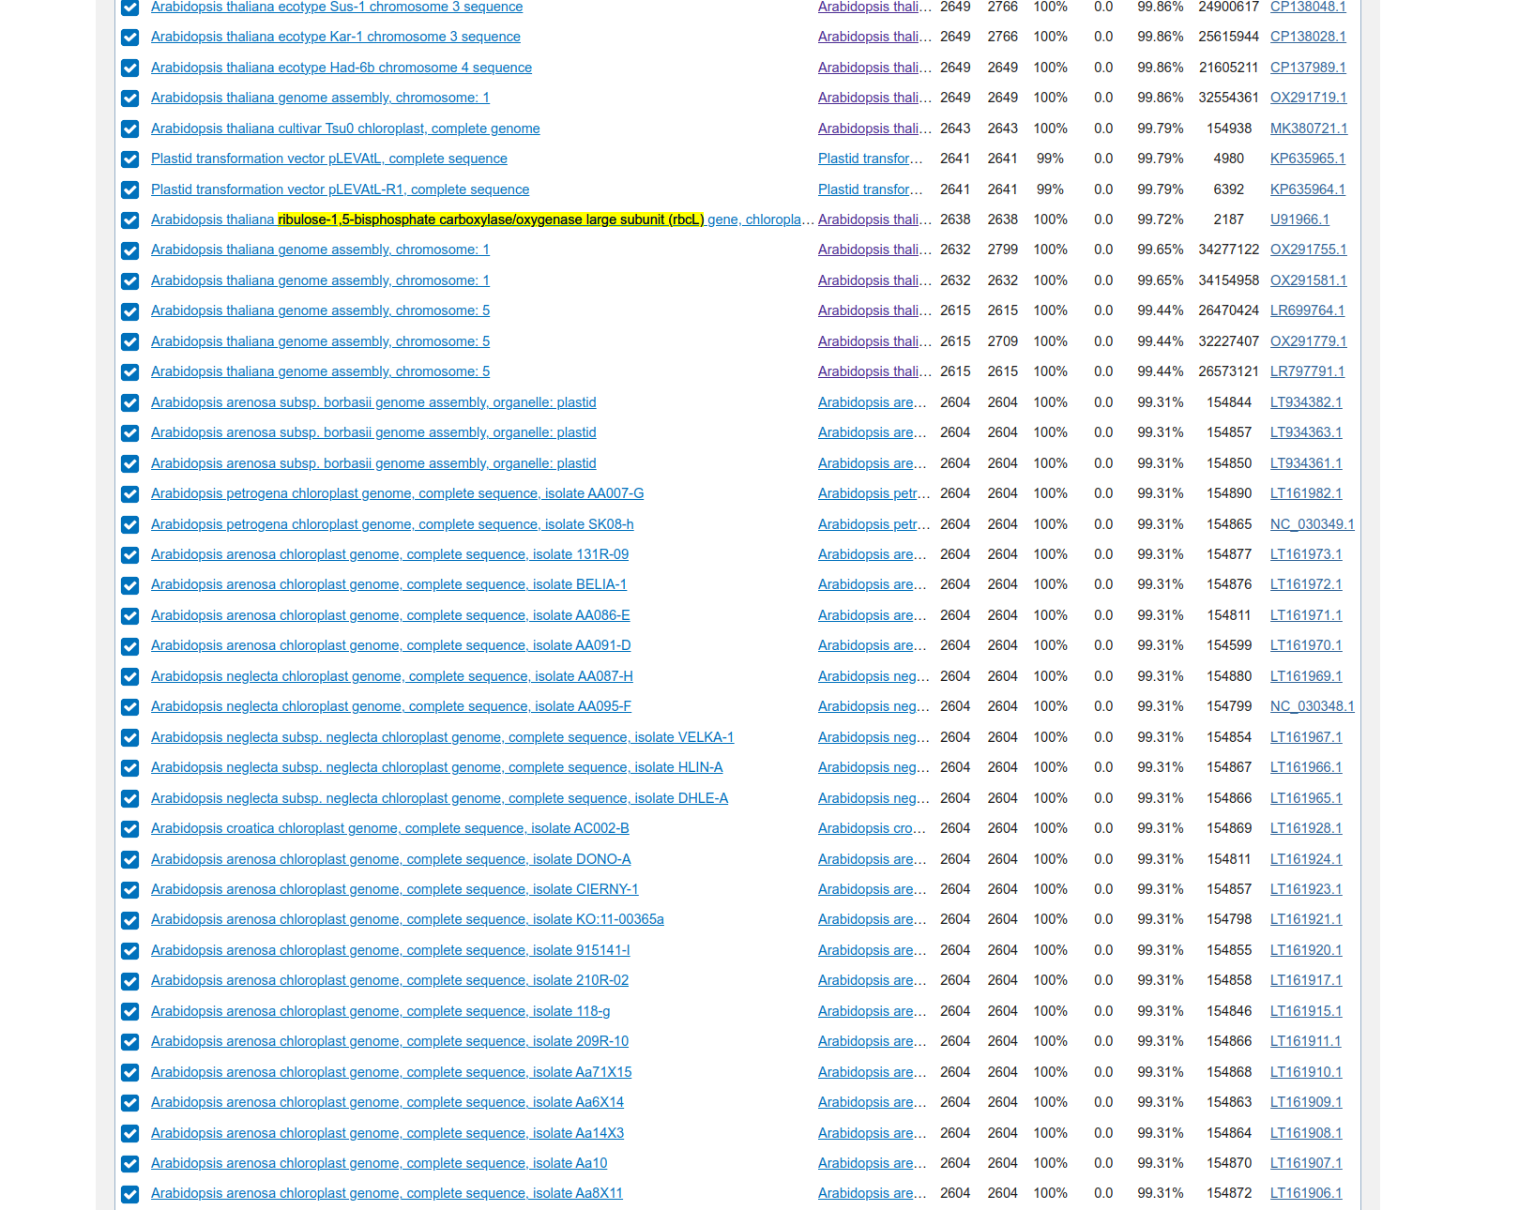

Results for Lilium

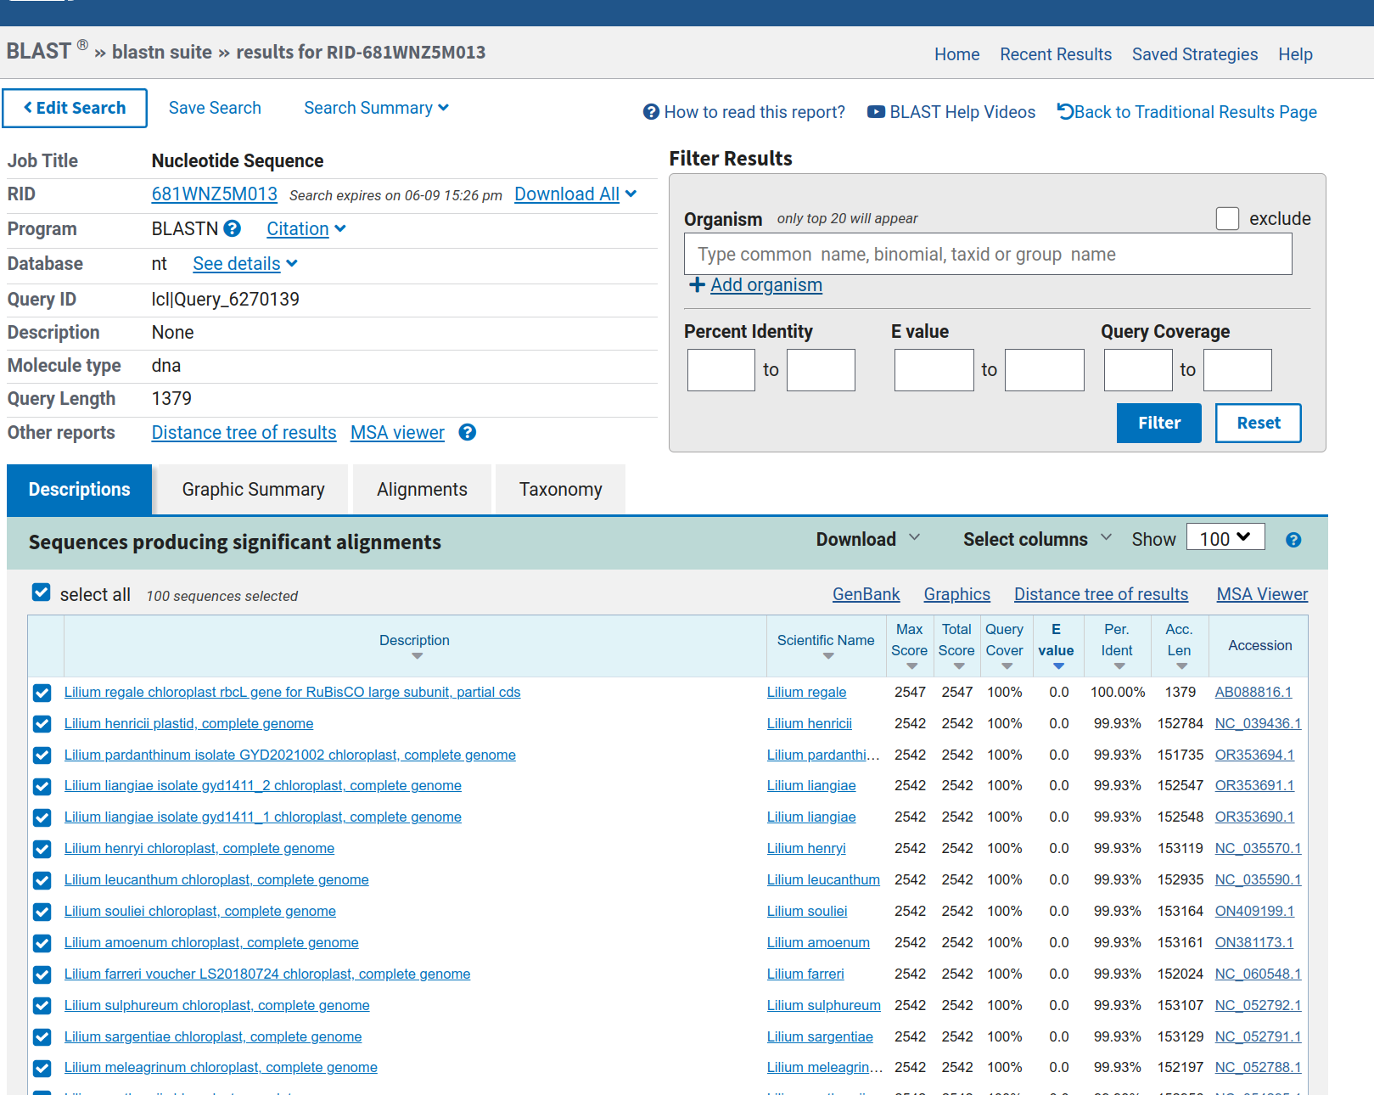

|  |  |  |
| --- | --- | --- |
| **Binomial Scientific Name** | **Percent Identical** | **E Value** |
| Chara aculeolata | 100 | 0.0 |
| Marchantia polymorpha | 100 | 0.0 |
| Polytrichum commune | 96.64 | 0.0 |
| Equisetum fluviatile | 100 | 0.0 |
| Serpocalum ptilhorizon | 100 | 0.0 |
| Pinus silvestris | 99.92 | 0.0 |
| Zamia erosa | 98.97 | 0.0 |
| Arabidopsis thaliana | 99.72 | 0.0 |
| Lilium regale | No match found | No match found |

Lilium did not return any results when searching for string:  
 **ribulose-1,5-bisphosphate carboxylase/oxygenase large subunit (rbcL)**

